**ROLL NO:2403A51028**

1. Write a Python code to calculate the sum of odd and even numbers in a given list using GitHub

Copilot along with VS Code. Use zero shot prompting

**Prompt**: Can you give a python code that read users input and calculates the sum of odd and even numbers in a given list

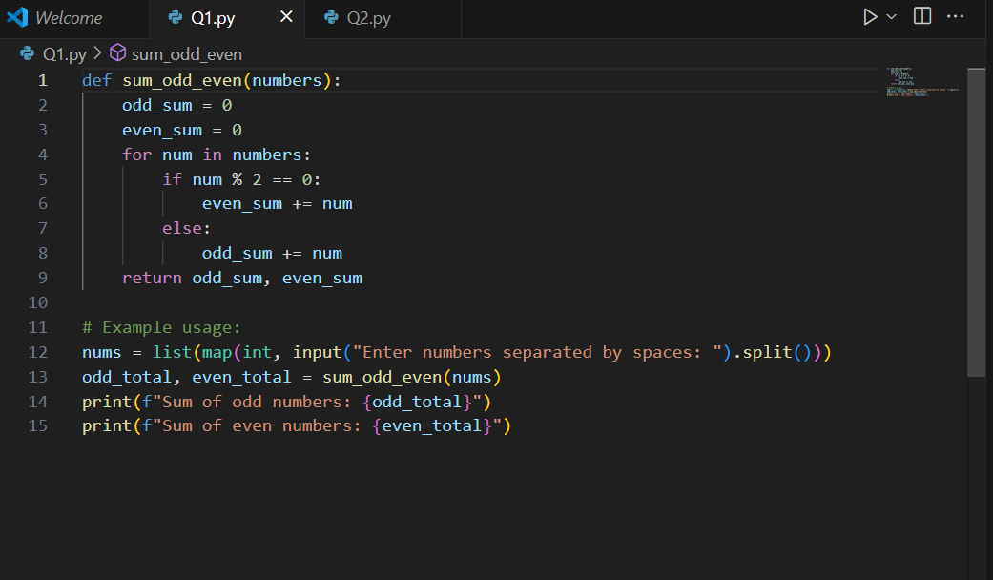

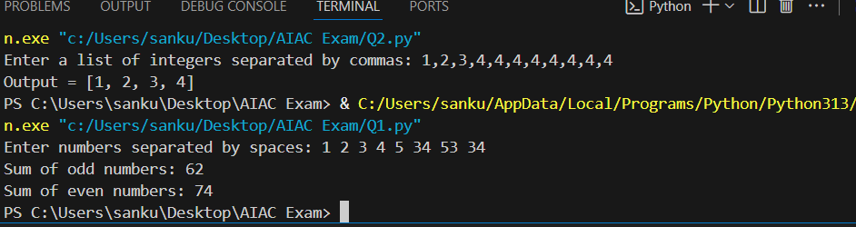

2. Write a Python code for given a list of integers, remove duplicates and print the sorted result.

GitHub Copilot along with VS Code. Use one shot prompting.

**Prompt**: can you give a python code that reads list of integers form user and remove duplicates and give a sorted result

Example: input = [1,2,3,4,5,6,6,6,7,4,5,6]

Output =[1,2,3,4,5,6,7]

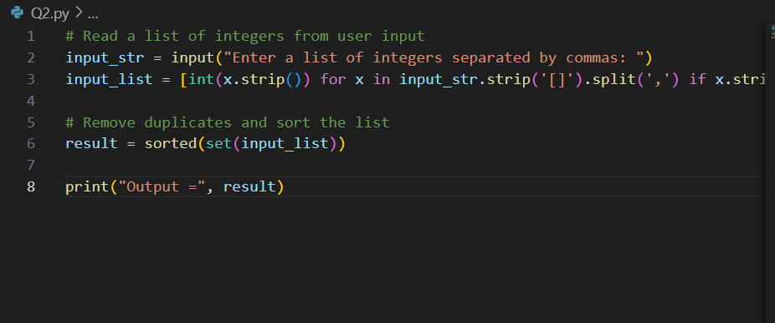

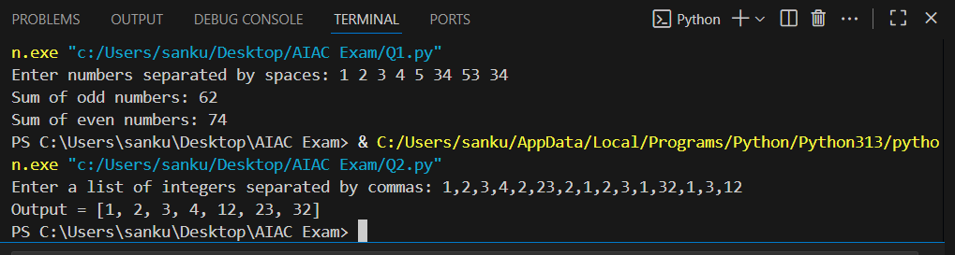

3. Write a Python function that converts the temperature between Celsius, Fahrenheit, and Kelvin

based on user choice. Use the Cursor AI tool. Use few shot prompting.

**Prompt**: Generate a python code that converts the temperature between Celsius, Fahrenheit, and Kelvin

based on user choice. And give output

Example1:celsius to Fahrenheit

32.0 Celsius = 89.6 Fahrenheit

Example 2:Fahrenheit to Kelvin

34.0 Fahrenheit = 307.15 Kelvin

Example 3: Kelvin to Fahrenheit

45.0 Kelvin = -378.66999999999996 Fahrenheit

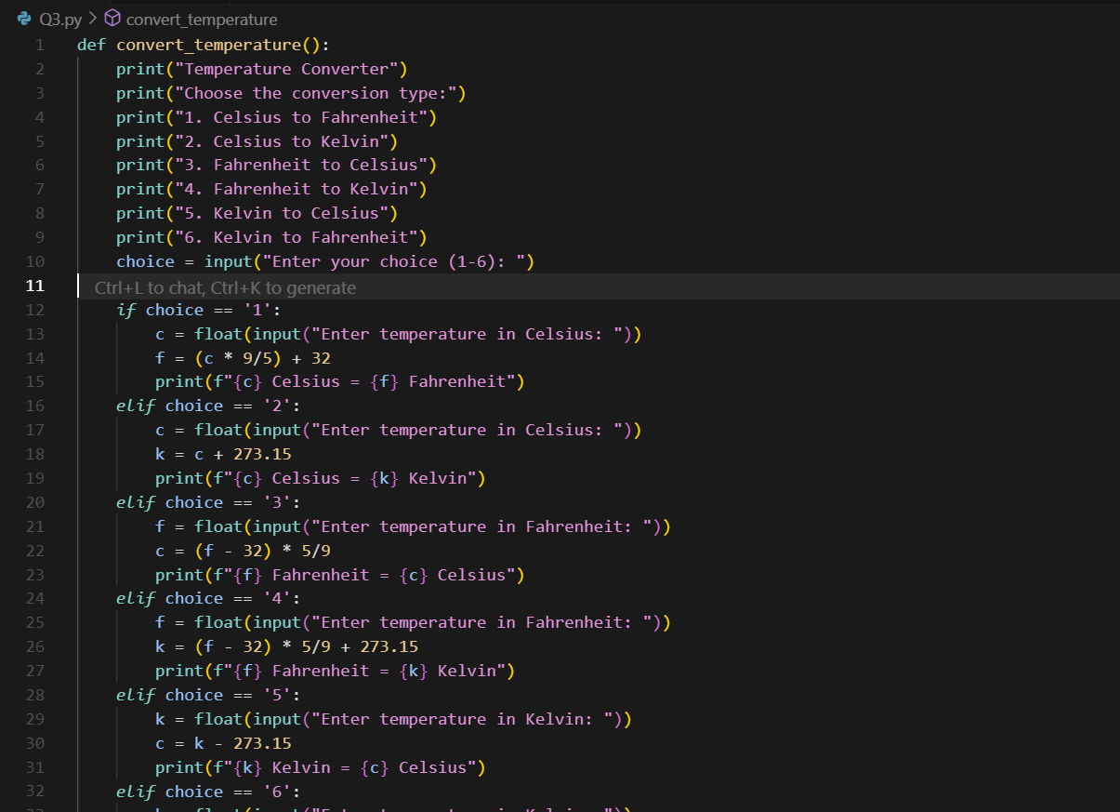

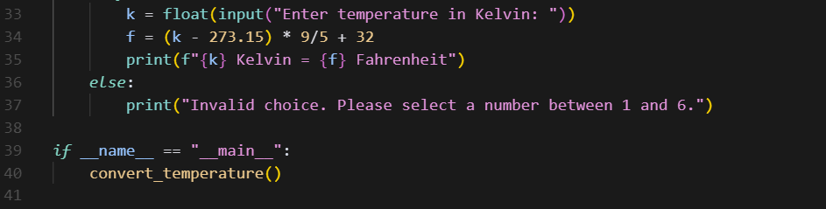

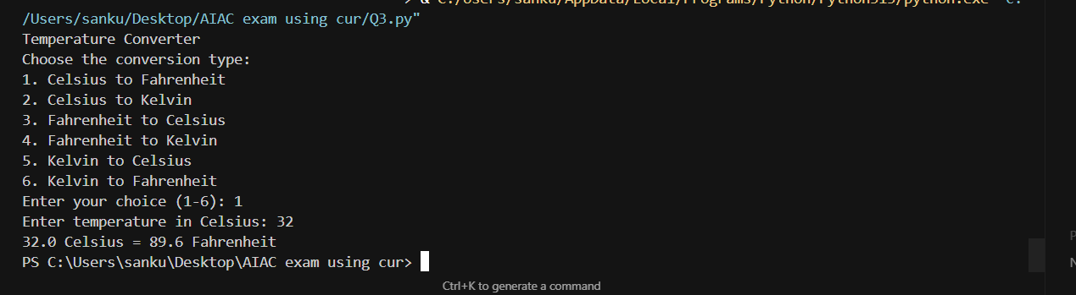

4. Write a Python function to remove punctuation, convert to lowercase, and remove stop words

from a given text. Use the Cursor AI tool. Use zero shot prompting

Prompt:

Can you write a Python function that removes punctuation, converts text to lowercase, and removes English stop words? The function should return the cleaned text with the message:ANd give output

